**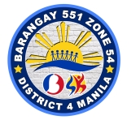 *Republic of the Philippines***

**BARANGAY 551 ZONE 54**

**DISTRICT IV, SAMPALOC, MANILA**

OFFICE OF THE BARANGAY CHAIRMAN



**ARMINDO E. LOYOLA**

***Barangay Chairman***

***Barangay Kagawad***

**LOURDES I. BERNARDO**

**NIDA D.C. MERCADO**

**CECILE L. MORALES**

**JOEL S. LIMBO**

**HERBERT G. SANTIAGO**

**VIRGINIA M. MADARANG**

**ALVIN M. BELGICA**

***SK Chairwoman***

**KYLA-LEI MANALESE**

***Brgy. Secretary***

**ROWENA D. CRESINES**

***Brgy. Treasurer***

**CARMELITA S. LIMBO**

***Brgy. Ex-O***

**Aristotelle B. Sudaria**

**CERTIFICATION**

TO WHOM IT MAY CONCERN:

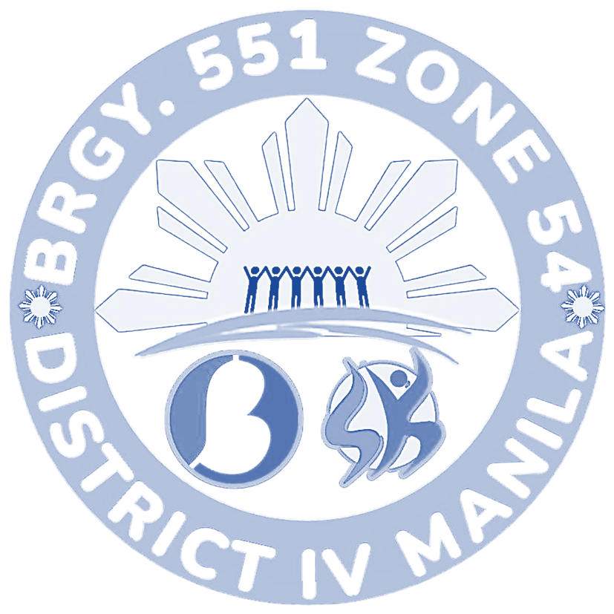

This is to certify that DAVY FLOREN MALIWAT LOYOLA of legal age, is a resident of Barangay 551 Zone 54, District IV with postal address at 348 San diego *St. Sampaloc,* ***Manila.***

This further certifies that the above named person exemplified good moral character and has no derogatory record in our community.

This certification is being issued upon the request of the above named person for Philhealth Purposes.

DONE and ISSUED this , 9th day of June 2025 at Barangay 551, Sampaloc, Manila.

Approved by:

__________________ ARMINDO E. LOYOLA

*Barangay Chairman*